West Hull Ladies
RRC

February Newsletter

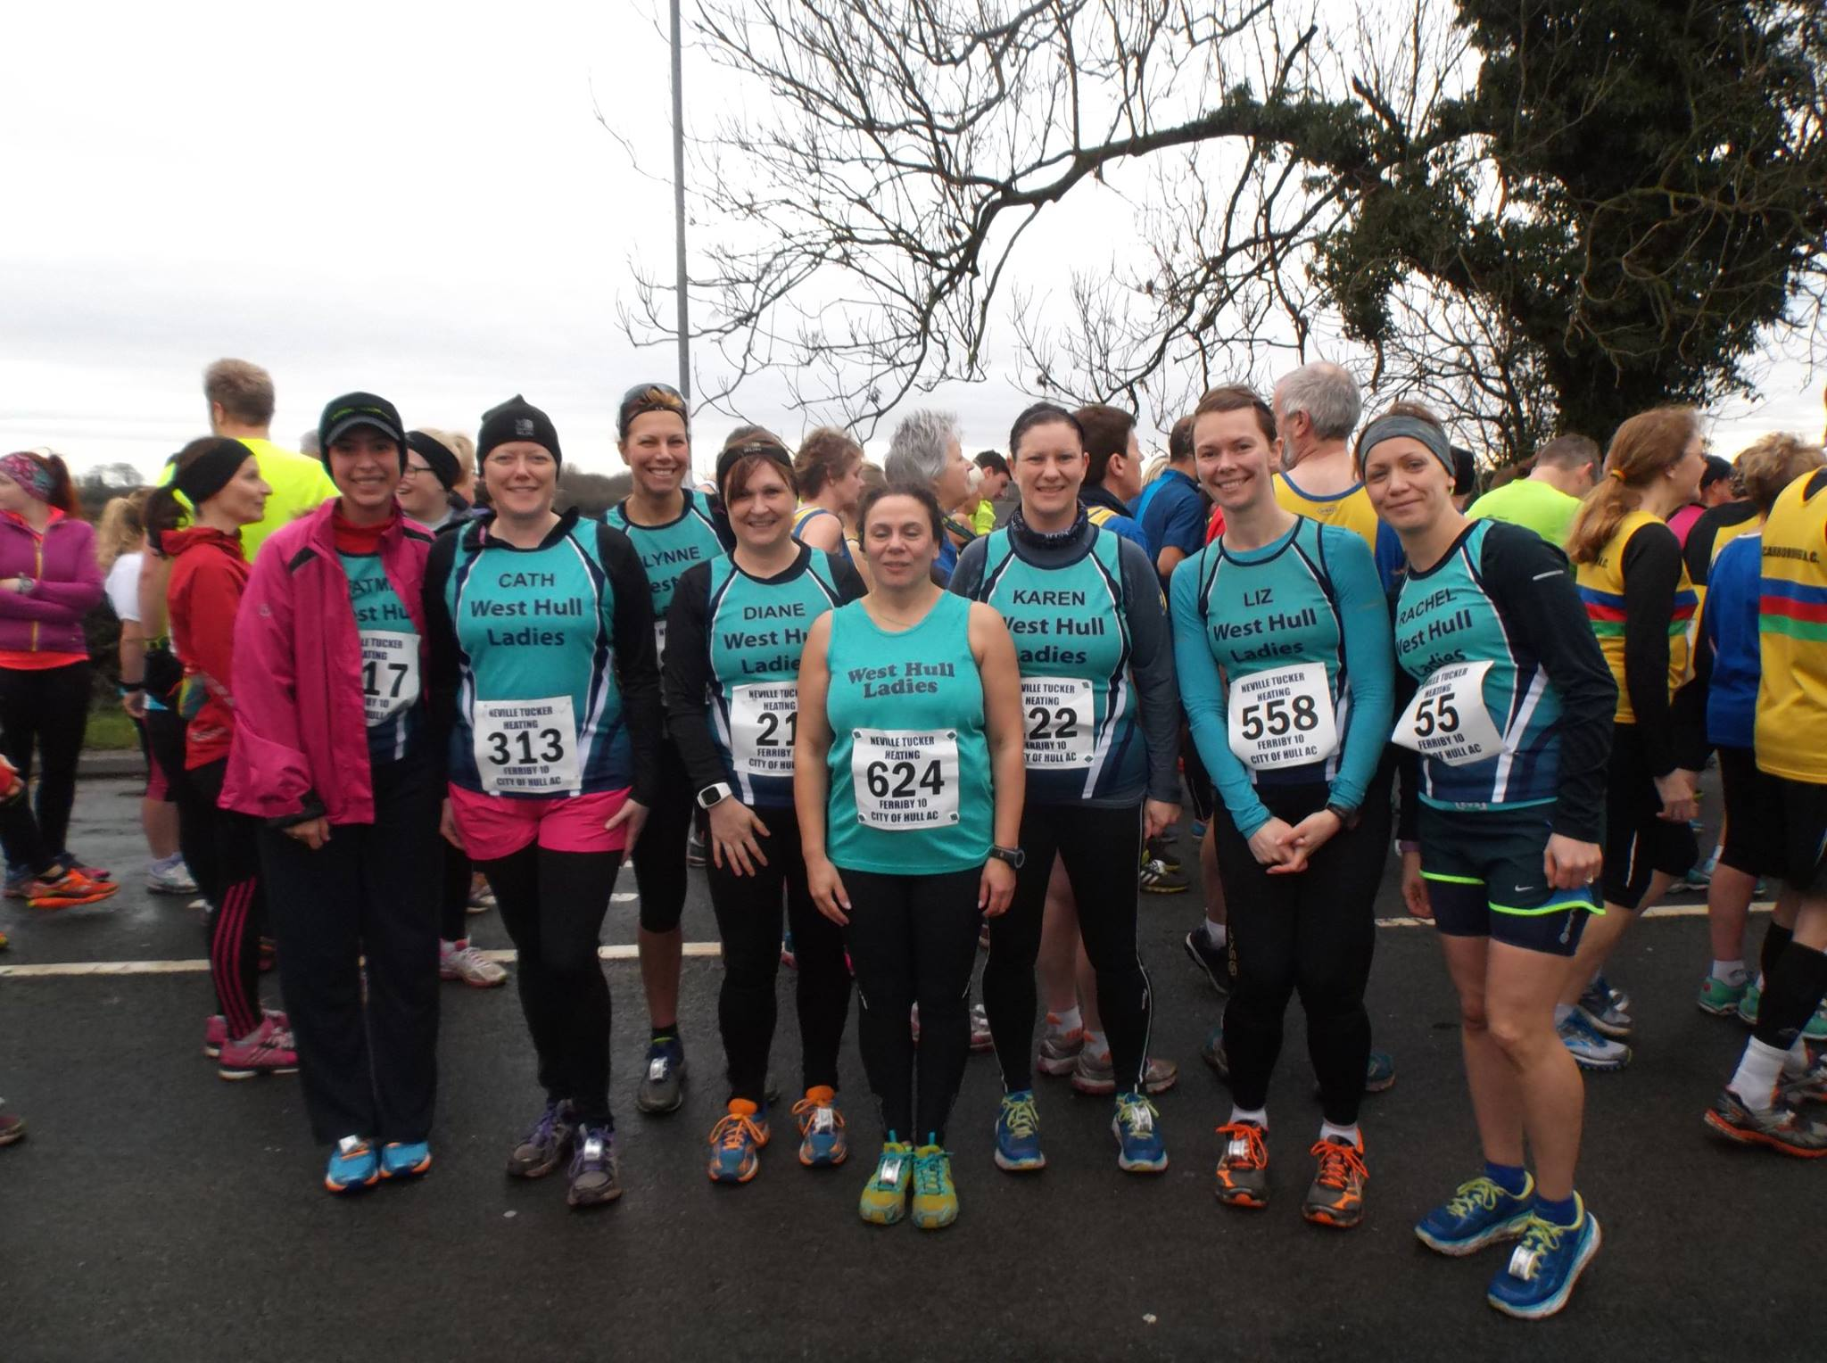

Ferriby 10 Ladies

West Hull Ladies
WEST HULL LADIES RRC COMMITTEE MEETING

Committee Meeting 1st February 2016
Minutes
Present - Jill, Karen, Linda, Amanda, Jan, Sandra

- Apologies received from Anna, Liz, Zoe, Annette, Maria, Rachael
- Minutes of previous meeting accepted as true record
- Updates - Jan confirmed she had booked the Back Room at Cottingham for the Presentation Evening on the 12th March. Jill confirmed the email informing members of the different awards had been sent out.
- Amanda updated members on the progress of the ladies involved in the 0-5k programme. The gait analysis had been organised with Humber Runner. Beverley 10k had confirmed the new ladies wishing to run the Beverley 10k would be able put down they were members of WHL and that an email giving details about the Park Run would go out tomorrow Tuesday 2.2.16.
- Jan updated everyone on the Presentation Evening. Jamie Barrington had accepted the offer of presenting the awards on the evening. Phil from City of Hull had also asked to attend the presentation evening. Discussed whether it might be a better option for Phil to attend the AGM Actions Jan to arrange menu with back room and keep the committee updated with progress. Jill and Linda to arrange ordering of awards. Jill to email Phil and ascertain which the better event to attend was.
- AGM - to take place March 7th. Action Amanda to see if a room was available at the Club, Jill to send out email explaining the different committee member roles and asking for volunteers and nominations for these. Jill also to include details of presentation night in the same email.
- AOB - Kris Lecher a sports therapist had asked if we as a club wished him to attend the Club one evening to give a talk on injury prevention. This was agreed and if possible to take place in April. Action Sandra to liaise.

Temple Newsom 10 miles : Jane

Tossing & turning all night so not much sleep wasn't the best way to start the day. After fuelling up on my usual- porridge, sweet freedom & chopped banana I gathered all my stuff together, which included a full change of clothes, pro-race nutrition, footwear etc. Any normal person would think we were going on holiday not competing in a race. Sarah picked me up at 7am & we set off.
On route we took a wrong turning so went on a scenic drive before consulting the satnav to get us back on course. Eventually we arrived at Temple Newsom estate, very grand, and a proper car park to leave our car.
It had been raining for a while so we made our way to main building to get our number & use the facilities. As it was still raining we waited in the car while it stopped then headed up to the start.
"They are moving"! I said to Sarah and we crossed the line into the muddy field. It was extremely wet and muddy from the start but we carried on regardless. Soon we were off the field and onto a bridleway but there was no let up. The puddles were huge and the mud was thick and swampy- trying to make your way round was like walking through treacle. We carried on down the track, mud everywhere we ran. It was a nice route through woodland until we emerged, stewards encouraging us all the way.
We crossed a road and we're running along a reservoir, the waters were so high it looked like it would burst at any minute. This was tough, it was extremely boggy and running through it was taking its toll on my poor legs. However other runners were gently encouraging each other & there was a great comradery between us.
Yippee we got to the water station at 7 miles. Stewards were shouting words of encouragement and handing out haribo' for energy. My legs were like lead by now, and my self-belief had taken a massive dive. I'd hit a wall, probably down to 3 hrs sleep. However Sarah stayed with me, Evan though I told her to carry on alone! It fell on deaf ears.
She stayed with me all the way. Another hill!. The steward was shouting words of encouragement as we made our way up an embankment, it was three slides forward, two back until we finally reached the top. Not far now. More mud!! By now we just ran through the puddles and mud as our feet were drenched and we were covered from head to foot anyhow.
A mile to go! "Nearly there" a steward chanted. What she didn't say was round the next corner was the sting in the tail? 800m to go, we could see the finish flag blowing in the wind! We trudged through the mud. It was tough but determination got us both over the line, everyone cheering us on all the way. We had done it. The muddiest, wettest challenge I've ever done! Sarah was my rock as always, she was phenomenal! Cheers matey!
Back at the car was a different challenge, how to get stripped off without getting covered in mud! By now all we cared about was getting warm & dry so all inhibitions went out the window!
I thoroughly recommend this race to ladies who love off road, hills & getting muddy. Not for the faint-hearted! An enjoyable challenge with a sting in the tail. X
Jane

Brass Monkey Half Marathon : Linda

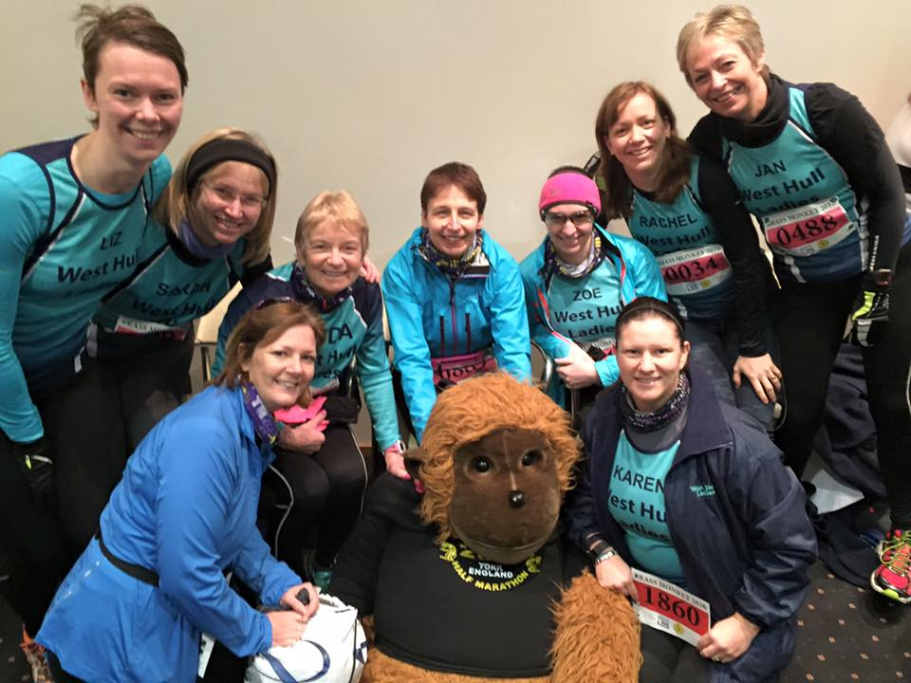

I managed to gain an entry into this half marathon after failing miserably last year (yes entries seem to get sold very quickly lately and you sure have to be on the ball)! The last time I ran it was in 2014 and there were only two of us running from WHL, Amanda and me. That day was cold and very wet!

This year 11 of us managed to gain a place, I just love it when all us ladies meet up at a race and there are so many of us. Although only 9 managed to get a photo taken with the Brass Monkey, he was probably the most popular ‘person’ that day. Wonder how many photos were actually taken of him with other runners? This year it was cold, very cold, there had been a flurry of snow overnight plus there was a heavy frost. At least I didn’t have to de-ice my car though as I was collected by the lovely Jill and Zoe and their car was already warm when I got in! We arrived nice and early, as you do, leaving plenty of time to settle down and use the loos at least 3 times (??!!) before the race. We were also exchanging ideas on what to actually wear. This wasn’t hard for, oh no, Just as much as I could possibly get on underneath my WHL long sleeve shirt (note to self ‘order an XXXXL one for next winter so I can fit more under it’)!

Then it was time to leave the warm building and take our positions at the start. Thankfully I started out with a dustbin liner on, this keeps the heat in and I learned the hard way in 2014 that it keeps you dry and warm until you’re ready to discard it. Then we were off.

I desperately wanted to at least run as fast as I did in 2014, my half marathon races in 2015 were lacking speed and I seemed to be getting slower. I had been trying harder with my training so as long as I didn’t panic then maybe there was a chance for me to get back to a decent half marathon time. I started off running with Rachel A and Jill J but they were way too fast for me and left me for dead. Jill, I’m sure, has little jet engines set into the heels of her shoes which her lovely sister Liz H has designed! So I settled into a lovely pace and was trying hard not to keep looking at my watch as the miles started to very slowly go by. Was I pleased to see the halfway marker, but by now I was getting cold, I couldn’t feel some of my toes as they were so numb, the sweat(!) had started to dry and I was feeling clammy but I continued and wasn’t going to let it get me down. There were three water stations and I had a sip of water at each of them but the water was so darned cold that I wish I hadn’t bothered. Next time must take a flask of hot tea round with me!

At mile 10 I was beginning to flag and believe it or not I was running on my own, there were some men just in front but still out of reach and I could hear some voices behind me but they weren’t close to me either. 1750 people and I was running on my own, unbelievable.

I caught up to the guys in front and they were running at a very nice pace and one I could keep up with so I tucked in behind them. Only three miles left, yay. The middle chap got a bit flustered with me behind him but I wasn’t moving even though he asked a couple of time if I wanted to pass! In the end they were having a banter about me and wondering which ‘bum’ out of the three I was watching! For once I wasn’t, honest, I was concentrating on my style and wondering whether I could keep it going, after all three miles is still a long way.

Towards the end there is a couple of flyovers, one is quite steep and I got left behind by the chaps but I didn’t stop running to walk, although I wanted to. On the down side of the flyover I caught up with them again. The next flyover isn’t quite so steep so I stayed with them. I knew once the second flyover was gone there wasn’t far to go so I did, in fact, overtake the chaps! (sorry guys).

The 800m sign was just in front of me and Sara Morrow from COH came storming past me, I couldn’t believe it she was behind me all this way and she was going to finish in front of me. Well I chased her and that was so tough as my legs were tired. 400m to go, just once round the track, but as this 400m wasn’t the track it actually seemed further and Sara was still in front. So I dug deep and managed to finish just a tad behind her (better luck next time Linda), then I could stop. Well that wasn’t such a good idea I actually felt sick so I knew I’d been working hard. So the hard work paid off, 2014 time was 1:55:41 and 2016 time was 1:52:52 which was the exact same time that Sara Morrow got too!

A massive well done to all our ladies who took part in this race, you were all awesome and I was very proud to be a member of West Hull Ladies.

Sarah JW, Andrea, Jane, Sarah F, Liz D, Jan D, Karen, Jill J, Zoe J, Rachel A you are all wonderful team mates.

Brass Monkey Half Marathon : Andrea

It had seemed such a good idea to enter a half marathon which took place in January – I thought I’d have lots of time over the Christmas holidays to get in my long runs – get up early in the morning while the kids were still in bed and knock out 8 or 9 miles before breakfast. Yes of course that’s what happened!! So unfortunately the week before I found myself pitifully under trained and still full of festive over indulgence. Karen very kindly accompanied me around a ten-mile slog, during which I questioned the wisdom of even turning up the following week, was I stupid to try it? Would the marshals all freeze to death waiting for me? Would the finishing line even be there when I finished? (if I even finished in one piece).

So after an afternoon of searching last year’s results on the internet, I decide that I would actually feel worse by bailing out and not taking part. I decided that I would deliberately run/walk the whole thing and just finish it. Once I made this decision, I was actually quite calm about it and looked forward to it!

Karen very kindly picked me up (I think it was mainly so that I had no excuse not to turn up) and with Rachel A already in the car we made our way to York race course where the race started and finished. We met up with most of the other WHL, and then went through the usual pre-race routine of faff with kit and race number, take group photo with stuffed monkey, go for a wee, share some lip balm, go for another wee, put hat on, take hat off, more lip balm, another wee?? No! you don’t need another one, put hat back on, oh! Is it that time? Walk to the start, position myself towards the back, generally complain about the cold and mutter what the hell was I thinking etc etc. And then we were off.

I’m not very good at remembering very clearly the different points in runs and races; but the general overall memory for me is that it was REALLY COLD, and when you don’t run very fast (and walk some bits) that it takes A REALLY LONG TIME to cover 13.1 miles under the power of your own legs - 2 hours 45 minutes and 9 seconds to be precise – which is 12 minutes slower than my first half marathon, but ok considering my lack of training. I ran to 6 miles, then planned on walking a minute for every mile after that, which I sort of did, although the walks got a longer and the running bits shorter the further I went.

It was wonderful to see so many WHL at the end – I didn’t think any of them would be hanging around in the cold, so thank you to all of you.

I wouldn’t exactly recommend attempting a half marathon under trained, but as I’ve done one before I had a fair idea of what it would be like and I’m very glad I did it. I wanted to show that longer distances are not only for the sub 9 minute milers, in fact the slower you are the longer you are actually trying for and that you can do more than you think you can.

Winter Running by Linda

Hello Ladies,

I saw this posted on another Ladies Running Site (Run Mummy Run). The lady that posted it is a runner herself and is a GP so all this advice is excellent.

I know from experience just how cold we can become while running especially in exceptionally cold, rainy, windy days. A great example was the Ferriby 10 in 2014. This was very wet, very cold, very windy and sleety too and although I had on lots of gear I was absolutely freezing towards the end. My lips were blue and I was shaking all over, I couldn’t even press the little button on my car key to open the door or even turn on the ignition (a kind man (Adrianna’s husband) did that for me). When I got home I couldn’t undo any of my running clothes, zips were a definite no no and my hubby had to undress me. By now I was really cold and my face was blue. Thank goodness finally undressed I could get into a hot shower. It did take me all afternoon to thaw out.

Runners are at risk of developing hypothermia when the temps drop this low. We can easily make the mistake of assuming we'll warm up as we run (guilty as charged here), but if the weather is very cold we can often fail to produce as much heat as our body is losing. Post-run symptoms of hypothermia range in
severity from mild-severe uncontrollable shivering, numb fingers and toes, loss of co-ordination, and confusion. If you've experienced any of those, it's worth considering what you can do to lessen the risk of developing hypothermia when you go out again. (I'm a runner, of course I'm not going to say don't run!)

We lose lots of heat from our head and hands, so a warm hat and gloves are a must. NOT a warm headband if it's really cold, as although your ears will be toasty you'll lose heat from the top of your head. We are at far higher risk of developing hypothermia if we get damp or wet, so if it's damp out there then a waterproof or showerproof jacket is a good idea. Stepping around puddles, if possible, or even investing in some waterproof socks (Seal Skinz are fab), is wise as wet, freezing feet lower your body temperature considerably.

Layers! Many of us hop about in frustration for a few minutes before we start a run as we wait to get a GPS. You might even need an additional layer if that is likely to happen, that you can then peel off and tie round your waist. If you're starting to turn into a block of ice, don't wait for the GPS, just run!

If it's really windy as well as cold, ideally head out into the headwind first, while your body is still warm, and run back with a tail wind that won't chill you so much for the later stages of your run. And head for the woods and the trails, where you'll have some protection from the wind, and it won't be quite so cold.

Warm up well when you get home and get out of any wet gear immediately. Warm woolly socks on! Hope that isn't too basic and doesn't sound patronising. I just wanted to remind people to stay safe, and enjoy your winter running.

Fundraising News
Linda is running the London Marathon and is raising funds for the charity
Boxer Friends Spain
www.gogetfunding.com/boxer-friends-spain.
"This is a new charity and I do lots of free work for them which even includes home checking so the charity knows their dogs are going to a good home. I help with foster dogs too and attend their fun days which always manages to raise some well needed funds. These Boxers are usually in a very poor state when they get rescued so quite often need lots of medical care as well as TLC."

Fatma is also running the London Marathon, for Refuge:
Hi ladies. I'm organising a ladies charity event to raise money for Refuge. (I am still short of target). It will be on Thursday 10th March 7-10pm at Goodfellowship Inn. Pre-paid tickets are £15. You can come along with family and friends. Hurry and don't miss a night of shows, music, food and more..." Thank you
Fatma

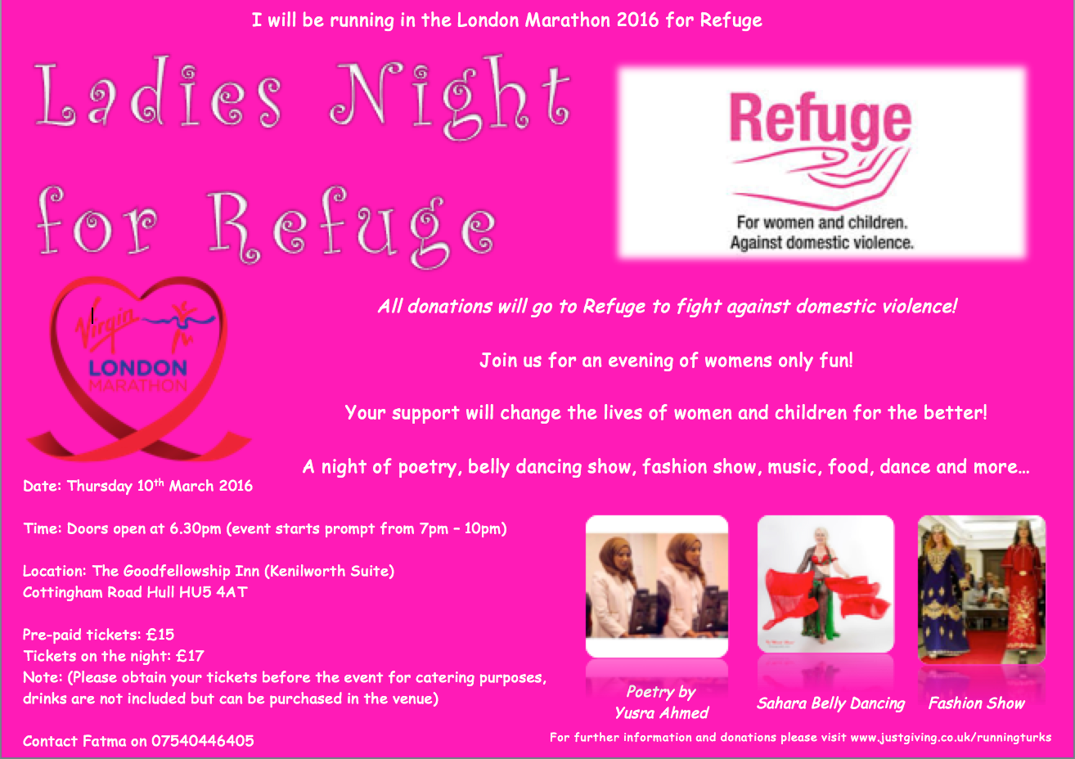

2016 RACE DIARY

Free 5K time trial every Saturday 9am:
Hull Parkrun Peter Pan Parkrun Humber Bridge parkrun

Double check dates, times and entry fees with the official website or the entry form. Zx Website contains all the links to the races: http://westhullladies.org.uk/races.htm

 | Date/Time | Event | Fee | Entry forms | Online entry
Feb  2016 | 21st/11:00 | Snake Lane 10 Mile | Race Full | Race Full | Race Full
 | 28th/09:00 | The Dalton Dash 10K | £14 UKA/£16 | Online entries only | Online entry
Mar  2016 | 5th/08:30 | Golden Fleece Circuit 15 Miles or 27.5 Miles | £14 | Entry Form | Online entry
 | 5th/10:00 | FlaminGO! 10K | £13 UKA/£15 | Online entries only | Online entry
 | 6th/11:00 | Norton 9 Mile | £8 UKA/£10 | Entry Form | Online entry
 | 13th/10:30 | Newton's Fraction Half Marathon | £18 UKA/£20 | Online entries only | Online entry
 | 20th/10:00 | Gainsborough 10K | £14 UKA/£16 | Online entries only | Online entry (+£0.75)
 | 20th/10:00 | East Hull 20 Miles | £20 UKA/£22 | Entry Form | Online entry (£1.80)
 | 25th/10:00 | Bridlington Easter 5 Mile Dash | £13 UKA/£15 | Entry Form | Online entry
Apr  2016 | 3rd/10:00 | Reading Half Marathon | £35 UKA/£41 | Online entries only | Online entry
 | 10th/TBC | Jane Tomlinson Yorkshire Half Marathon, Sheffield | £30.10 UKA/£32.10 | Online entries only | Online entry
 | 10th/TBC | Greater Manchester Marathon | £58 UKA/£60 | Online entries only | Online entry
 | 10th/11:00 | Hornsea Third Marathon | £12 UKA/£14 | Entry Form | Online entry
 | 17th/11:00 | Jane Tomlinson City of Lincoln 10K | £24.75 UKA/£26.89 | Online entries only | Online entry
 | 17th/11:00 | Burton Pidsea 10K | £11 UKA/£13 | Online entries only | Online entry
 | 24th/TBC | Virgin Money London Marathon | Race Full | Race Full | Race Full
May  2016 | 8th/09:30 | Jane Tomlinson Leeds Half Marathon | £30.10 UKA/£32.10 | Online entries only | Online entry
 | 8th/11:15 | Beverley 10K | £13 UKA/£15 | Online entries only | Online entry
 | 15th/09:00 | North Lincolnshire Half Marathon | £26 UKA/£28 | Online entries only | Online entry
 | 15th/TBC | Jane Tomlinson Nottingham 10K | £25.82 UKA/£27.96 | Online entries only | Online entry

NOTE: Club Vests must be worn at any races you enter
under the West Hull Ladies running club name.

Kit Order Form

NEW STYLE VESTS are purchased direct from www.pbteamwear.co.uk
On website: click on Clubs, Athletics Club, West Hull Ladies RC
Pick your size, name you wish to have on the front and follow payment instructions

For all other purchases use this form.

FORENAME ___________________________________
SURNAME ___________________________________

ORDER - tick what you require and circle your size Price
- OLD STYLE VEST SIZE 10 12 £10.00 (useful for training)
- LONG SLEEVED SIZE 10 12 14 16 £18.50 £10.00 (useful for training)
- HOODIE SIZE XS S M L £20
- HOODIE with ZIP SIZE XS S M L £20
Note on size: M is approximately size 14

- BEANIE HAT £6.50
- PINLESS WHL NUMBER FASTENERS (set of 4) £3.00

DATE Ordered _______________
AMOUNT PAID _______________

Please transfer payments online with your name and marked as ‘Kit to:
Account: 63762742 Sort Code: 20 43 49

Or cheque payable to ‘West Hull Ladies RRC’, and write your name and ‘Kit’ on the back and give to Club Treasurer Linda Dodsworth, 110 The Stray, South Cave, E Yorkshire. HU15 2AL

Sign on receipt of goods _________________________________
DATE _______________

Please complete this form and email to diazmaria@btinternet.com
Thanks.
Maria Kit Officer

